Momentum Strategy Implementation

1. PARAMETERS
Formation period: J ∈ {3, 6, 9, 12} months
Holding period: K ∈ {3, 6, 9, 12} months
Skip period: 1 month

2. DATA FILTERS
P_{i,t} ≥ $5
SHRCD ∈ {10, 11} （U.S common stock）
EXCHCD ∈ {1, 2, 3} （the NYSE, AMEX, or NASDAQ ）

3. FORMATION PERIOD RETURN
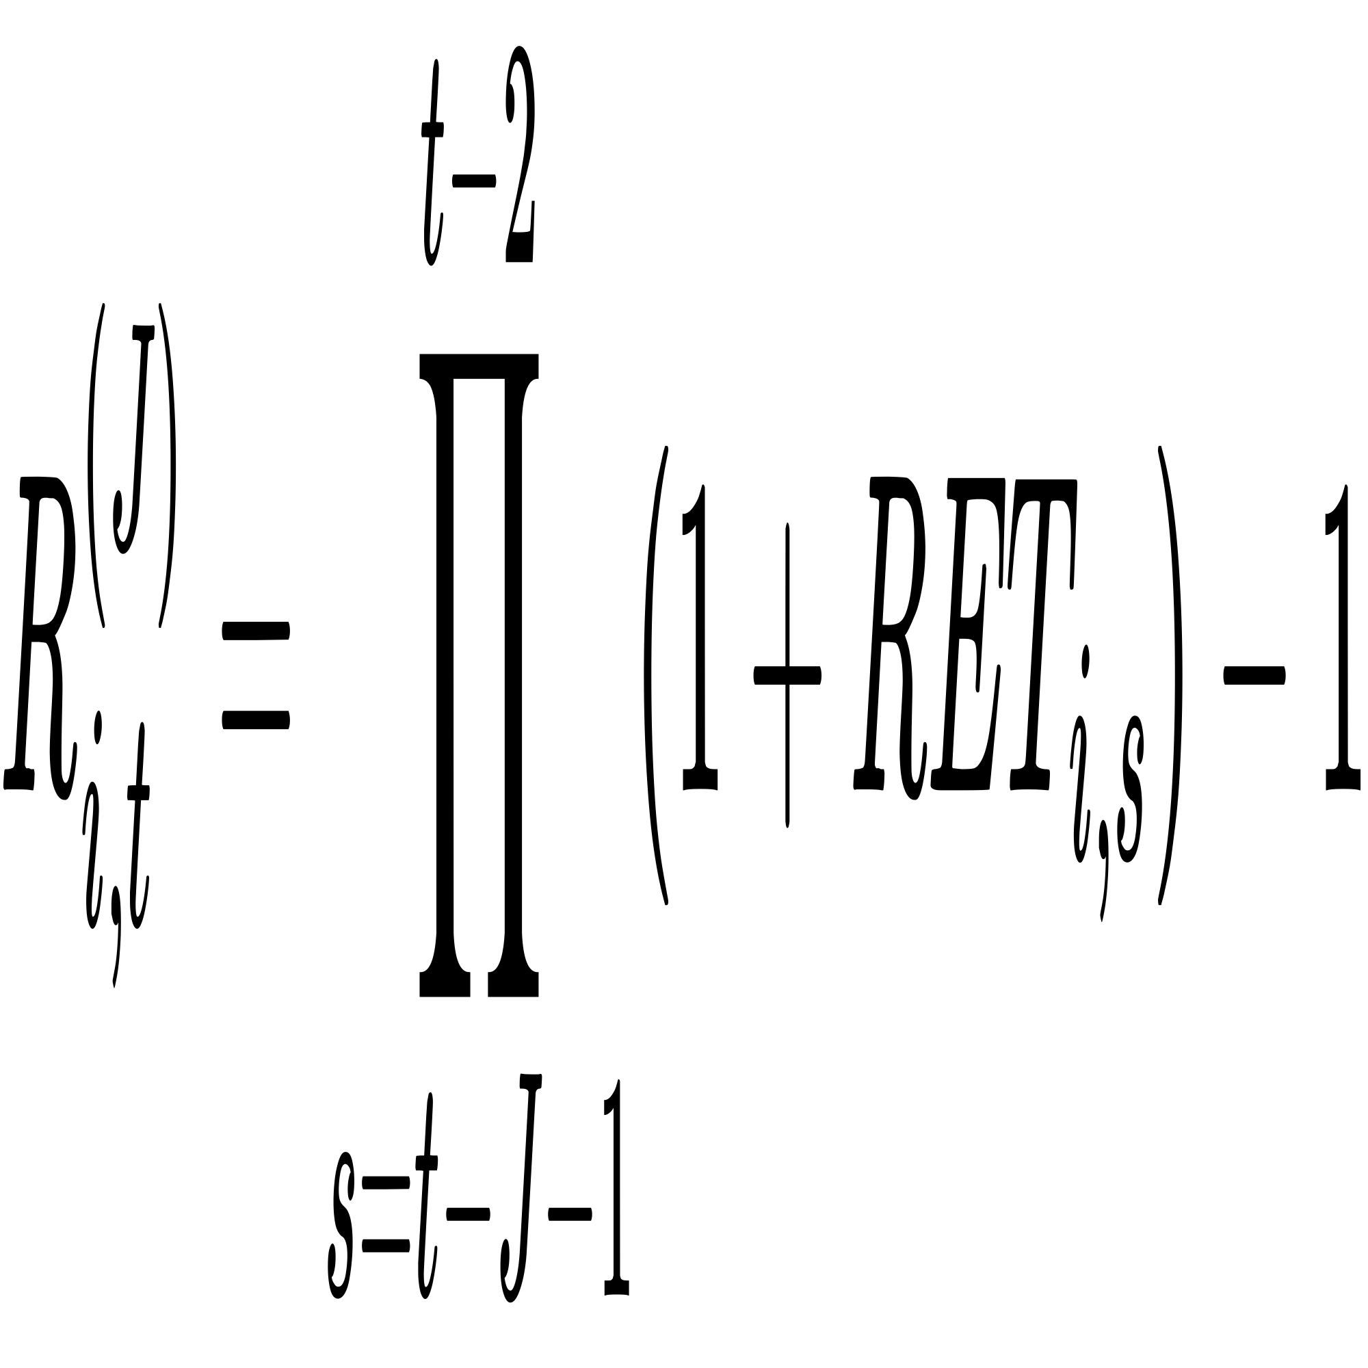
where RET_{i,s} is the monthly return of stock i at time s.

4. PORTFOLIO CONSTRUCTION
Ranking: Rank stocks by R_{i,t}^{(J)} (ascending).
Deciles: Decile 1 (Losers): Bottom 10% Decile 10 (Winners): Top 10%
Weights:(a) Equal-Weight: w_{i} = 1/N
(b) Value-Weight: 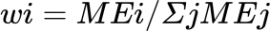

5. WINNER-MINUS-LOSER PORTFOLIO

6. OVERLAPPING PORTFOLIOS

7. PERFORMANCE METRICS
(1) Cumulative Return:
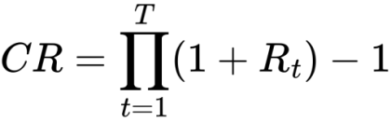
(2) t-statistic:
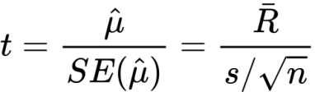
(3) Sharpe Ratio (annualized):
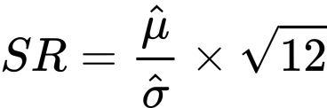
where μ̂ = mean monthly return, σ̂ = monthly standard deviation

